Red-Eye Instrument PreamplifierTM

The Red-Eye Instrument Preamp offers a simple, one-box, direct-connect solution to musicians playing instruments with high-impedance piezoelectric pickups…for example, the L.R. Baggs violin bridge pickup. Any passive instrument pickup is supported.

The Red-Eye Preamp’s high input-impedance allows piezoelectric pickups to operate essentially unloaded, which results in a smooth, natural, acoustic instrument tone. Low distortion, low noise, and generous headroom mean clear tone comes through even when an instrument is played percussively and loudly. The Red-Eye Preamp also works well with instruments that have active pickups or magnetic pickups, such as electric guitars and electric basses.

Features…

- Input: high-impedance, 1 million ohms, maximum 1 volt peak-to-peak level.
- Low-impedance, balanced, XLR output, 600 ohms, will drive long cables to mix-board.
- Boost button with volume control for amplifying solos.
- Treble control to boost or reduce treble.
- Long 9-volt battery life (~200 hours).
- Automatically uses 48-volt XLR Phantom Power, when available, instead of the battery.
- Plugging an instrument in or connecting XLR phantom power turns the Red-Eye on.
- Automatic power check: Power Chk Light flashes for 1 second if power is good when preamp is powered up. When powered up on the battery (without XLR Phantom Power) the battery gets tested and the flash happens as long as the battery is in the first ¾ of its life.
- ¼ inch output and input for accessory loop, suitable for stomp-tuners or effects boxes or for output to on-stage guitar amps or PAs.
- Internal filtering to reject radio-frequency interference from neon lights and cell phones.
- Small Size: 1.25 x 2.25 x 4.25 inches. Weight: 10 ounces.

XLR Output to Sound System
Boost Button
¼-inch Output to Accessories
¼-inch Input
from Accessories
Boost Volume Control
¼-inch Instrument Input
Power Chk Light
Treble Control
Red-Eye
Instrument Preamplifier
Balanced
Output
Effects
Loop
Treble
Boost
Instrument
Boost Light

Red-Eye Preamp Signal Path…

- The Instrument Input impedance is 1,000,000 ohms.
- The Effects Loop Output impedance is less than 4,000 ohms.
- The Effects Loop Input impedance is 4,000 ohms.
- The XLR Output impedance is 600 ohms.
- Frequency response is flat from 10 Hz to 20 KHz when Treble Control is centered.
- Boost level above no Boost: Minimum Boost = +2 db, Maximum Boost = +7 db
- Noise Floor is 126 db below 1V peak-peak input level.
- Total Harmonic Distortion is less than 0.05% at 1V peak-peak input level.

High Input Impedance Amplifier
Instrument
Boost Level Control and Boost Button
Treble Control
Output To Effects or to PA
Input From Effects
Balanced
XLR
Output
Isolation Transformer
This connection opens when the
Effects Loop Input
is used.

Using the Red-Eye Preamp to connect your instrument to a club’s sound system…

- You have control over your instrument’s treble.
- You have control over solo boost if you need it.
- If you turn on a Stomp-Tuner, the XLR output to the Mix Board will be muted.

Red-Eye Preamp

Effects Loop
Output Input
Instrument
XLR Cable
to Mix Board
Input Output

Stomp-Tuner
(optional)

Using several effects boxes or a pedal board with the Red-Eye Preamp…

- Connect Effects and/or a Stomp-Tuner in series to the Red-Eye Preamp Effects Loop.
- Effect Boxes and/or Stomp-Tuner will affect the XLR output to the Mix Board.

Red-Eye Preamp

Effects Loop
Output Input
Instrument
XLR Cable
to Mix Board
Input Output

Effect #2

Input Output

Stomp-Tuner
Input Output

Effect #1

Using the Red-Eye Preamp with an on-stage Guitar Amp or Instrument PA…

- Add any effects boxes you want in series between the Red-Eye Preamp and the PA.
- Red-Eye Preamp works to control the instrument’s treble and gives you a solo boost button.

Red-Eye Preamp

Effects Loop
Output Input
Instrument
Input

Guitar Amp
or other PA

Using the Red-Eye Preamp as a passive direct interface…

- The Red-Eye can also be used as a high-quality passive DI box. The isolation transformer used in the Red-Eye Preamp has a nearly linear response from 18 Hz to over 30 KHz.
- Power is not required
- 4,000 ohm input-impedance, single-ended input
- 600 ohm output-impedance, balanced XLR output

Red-Eye Preamp

Effects Loop
Output Input
Single-Ended
Quarter-Inch Cable
XLR Cable
to Mix Board

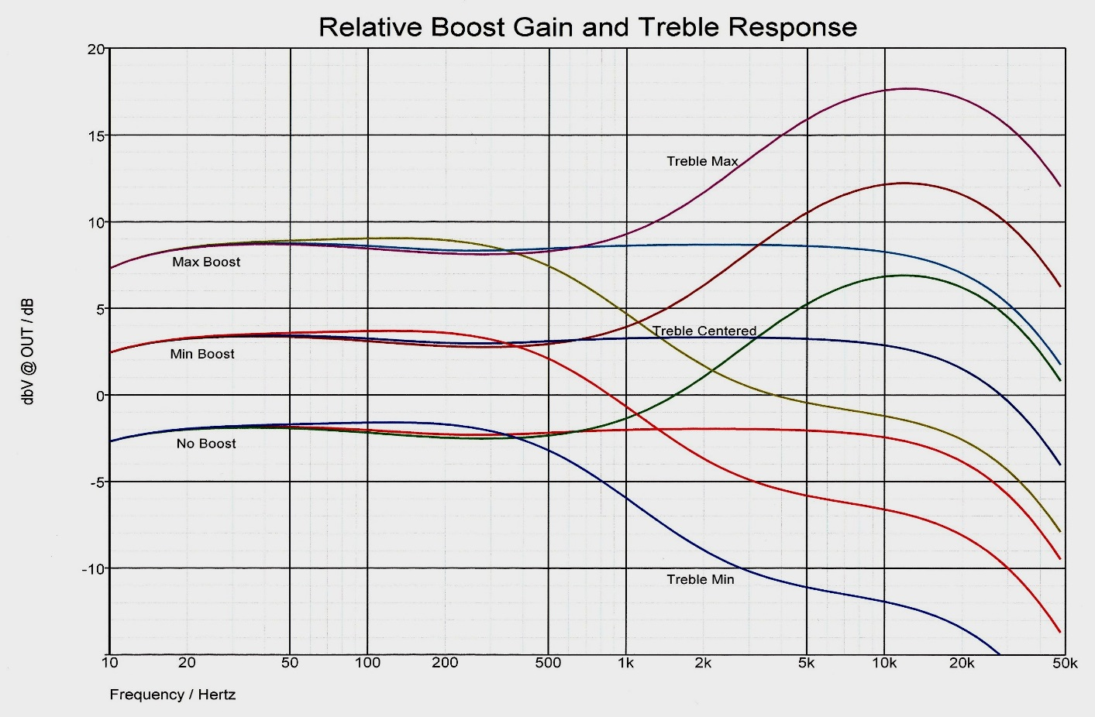

For additional information, contact…

Fire-Eye Development: www.fire-eye.com
Fire-Eye Development: 512-346-6944
Justin Jacobs: justin@fire-eye.com
Daren Appelt: daren@fire-eye.com

Red-Eye Instrument Preamplifier is a trademark of Fire-Eye Development, Inc.

