Bright-Eye Clean Boost / BufferTM

The Bright-Eye is a clean boost and buffer pedal that uses a 9V or 18V center-negative power supply, bringing the hi-fidelity signal-conditioning circuitry of the Red-Eye Preamp to a pedal-train format.

The Bright-Eye offers high input-impedance, high input headroom, and a dynamic high-end frequency attenuation switch.

Features…

- Input: high-impedance, 1 million ohms, maximum 12 volt peak-peak level.
- Low-impedance output, 600 ohms, will drive all guitar pedals and amps effectively.
- Clean, unclipped, output level, 9V power: 5V peak-peak, 18V power: 12V peak-peak
- High-Quality Switchcraft 1/4-inch input, output and power jacks.
- Boost button with volume control and boost light.
- A light beam and photocell control boost to eliminate all button noise and popping.
- A Mode switch selects flat or shaped frequency response.
- Uses standard 9 or 18-volt pedal board, Boss-style, power: (center-negative, center-ground).
- Internal filtering to reject radio-frequency interference from neon lights and cell phones.
- Small Size: 1.25 x 1.5 x 3.75 inches. Weight: 6 ounces.

Boost Button
¼-inch Output
¼-inch
Input
Boost Volume Control
Bright-Eye
Clean Boost / Buffer
Boost Light
www.fire-eye.com
9-Volt or 18-Volt Power
Mode Switch
Shaped Mode
Flat Mode

Bright-Eye Clean Boost / Buffer Signal Path…

- The Input impedance is 1,000,000 ohms.
- The Output impedance is 600 ohms.
- Boost Volume has a 20 db range (1 : 10 voltage ratio)
- In shaped mode, high frequency harmonics are reduced as boost is increased.
- Frequency response is +/-1 db from 10 Hz to 20 KHz in Flat Mode.
- Noise Floor is 136 db below 10V peak-peak output level.
- Total Harmonic Distortion is less than 0.05% at 10V peak-peak output level.

Harmonic Shaping…

We designed the Bright-Eye’s shaping to be dynamic as the boost control is advanced. The bottom line of the graph below shows the frequency response of the Bright-Eye to be flat when the boost is off or the knob is at zero. As the boost knob is advanced to ten, the high frequencies from an instrument are boosted less and less compared to the low and middle frequencies.

Shaped Mode as Boost is Increased
(Knob positions 0 through 10)

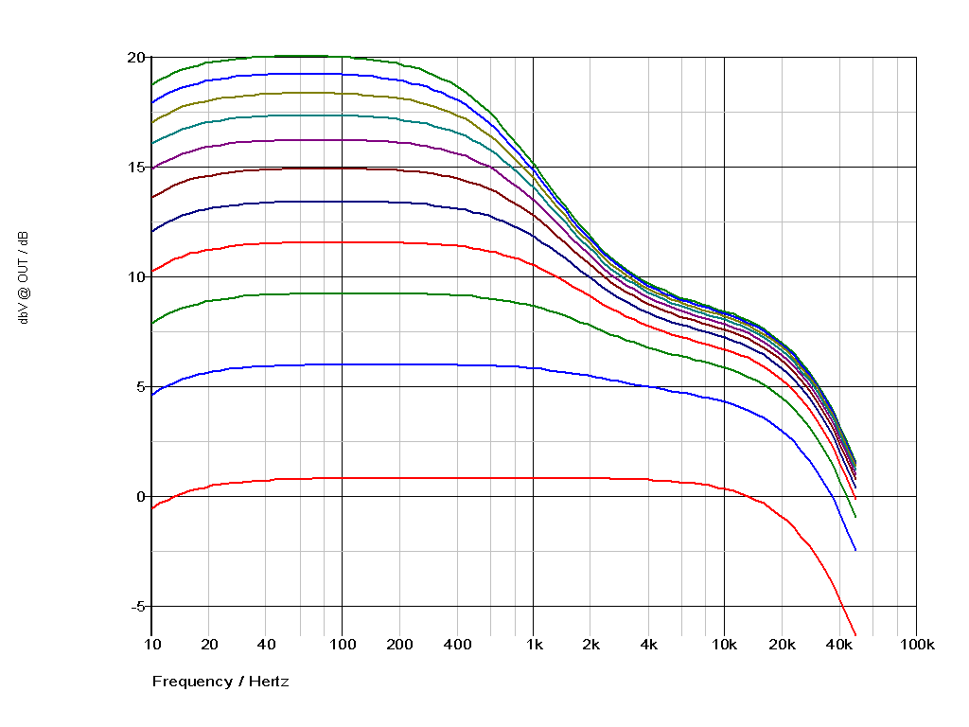
Frequency response and gain relative to input signal.

Flat Mode as Boost is Increased
(Knob positions 0 through 10)

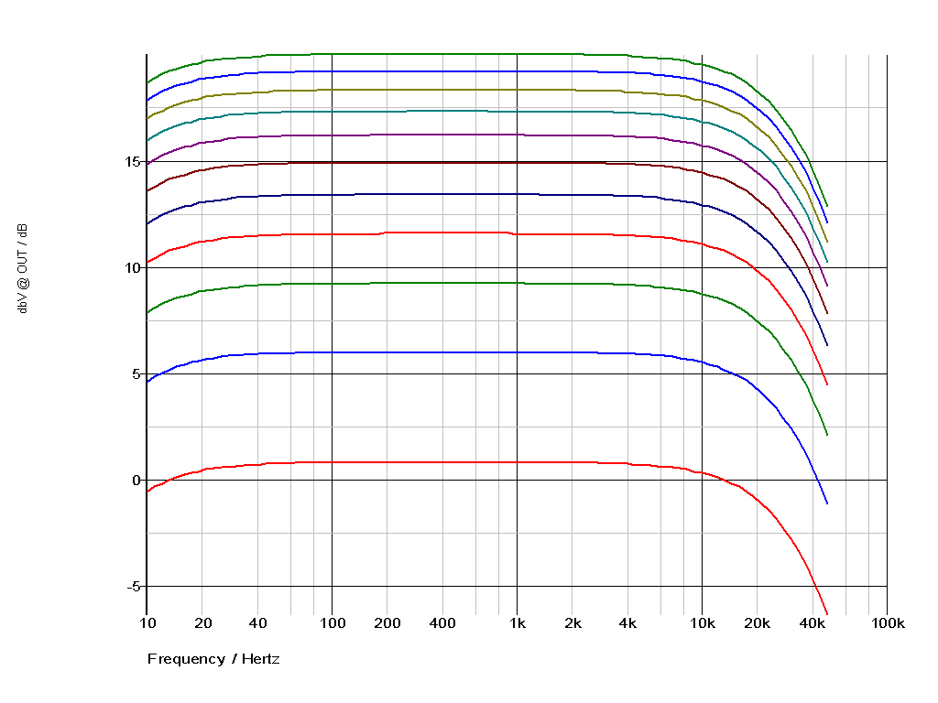
Frequency response and gain relative to input signal.

For additional information, contact…

Fire-Eye Development: www.fire-eye.com
Fire-Eye Development: 512-346-6944
Daren Appelt: daren@fire-eye.com
Justin Jacobs: justin@fire-eye.com

Bright-Eye Clean Boost / Buffer is a trademark of Fire-Eye Development, Inc.

